Bse243163

Ayesha Jami

**Practice Task 1:**

#include<iostream>

#include<cmath>

using namespace std;

class Arc{

private:

double radius;

double angle;

double arc_length;

public:

void setRadius(double r){

radius=r;

}

void setAngle(double a){

angle=a;

}

void setArc_length(double arc){

arc_length=arc;

}

void readValues() const{

cout<<"Radius:"<<radius<<endl;

cout<<"Angle:"<<angle<<endl;

cout<<"Arc Length"<<arc_length<<endl;

}

void calculateArcLength(){

arc_length=(angle/360)*2*M_PI*radius;

}

};

int main(){

Arc myArc;

myArc.setRadius(5.0);

myArc.setAngle(90.0);

myArc.calculateArcLength();

myArc.readValues();

return 0;

}

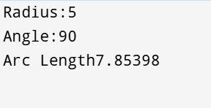

**Practice task 2:**

#include <iostream>

#include <string>

using namespace std;

class Android_Device {

private:

int IMEIno;

string Type;

string Make;

int Modelno;

float Memory;

string Operating_System;

public:

void setValues(int imei, string t, string m, int mNO, float mem, string os) {

IMEIno = imei;

Type = t;

Make = m;

Modelno = mNO;

Memory = mem;

Operating_System = os;

}

void displayValues() {

cout << "IMEI Number: " << IMEIno << endl;

cout << "Type: " << Type << endl;

cout << "Make: " << Make << endl;

cout << "Model Number: " << Modelno << endl;

cout << "Memory: " << Memory << " GB" << endl;

cout << "Operating System: " << Operating_System << endl;

}

};

int main() {

Android_Device myDevice;

myDevice.setValues(123456789, "Smartphone", "Samsung", 101, 64.5, "Android");

myDevice.displayValues();

return 0;

}

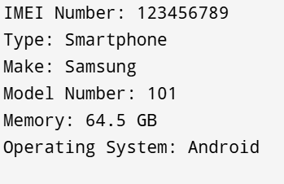

**Practice Task 3:**

#include <iostream>

#include <cmath>

class Quadrilateral {

private:

double side1, side2, side3, side4;

double angle1, angle2;

public:

void setValues(double s1, double s2, double s3, double s4, double a1, double a2) {

side1 = s1;

side2 = s2;

side3 = s3;

side4 = s4;

angle1 = a1;

angle2 = a2;

}

double computeArea() const {

double s = (side1 + side2 + side3 + side4) / 2;

return sqrt((s - side1) * (s - side2) * (s - side3) * (s - side4));

}

return side1 + side2 + side3 + side4;

}

void displayDetails() const {

std::cout << "Sides: " << side1 << ", " << side2 << ", " << side3 << ", " << side4 << std::endl;

std::cout << "Angles: " << angle1 << "°, " << angle2 << "°" << std::endl;

std::cout << "Perimeter: " << computePerimeter() << std::endl;

std::cout << "Area: " << computeArea() << std::endl;

}

};

int main() {

Quadrilateral quad;

quad.setValues(5, 7, 5, 7, 60, 120);

quad.displayDetails();

return 0;

}

